Homework 1: Cell Population
Valeria Diaz Matias
Human Physiology for Engineers
Florida Gulf Coast University
January 26, 2025

Problem 1.)

1.)



2.)
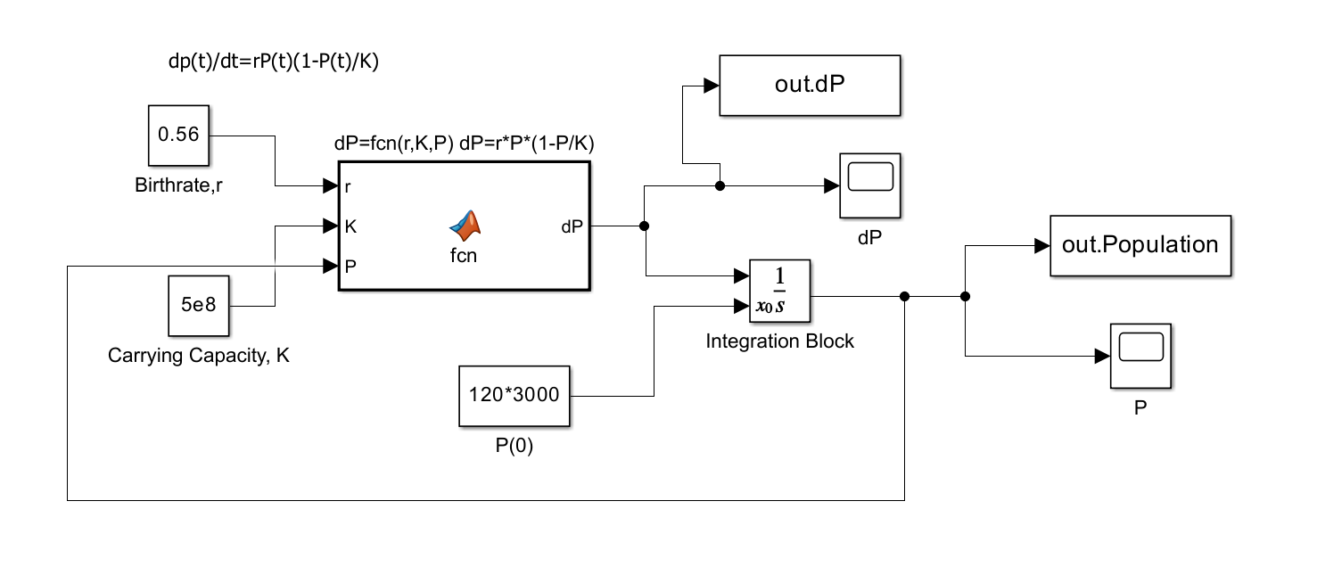
For the first graph, the model’s nature is one of an exponential growth pattern that flattens out once it has reached carrying capacity, which occurred after 15 days. The graph for change also followed an exponential growth pattern but also decreased after the peak was reached at 8 days.
3.)
a.) The Petri dish will reach 80% saturation after 15 days, 9hrs, 30mins and 0 sec.
b.) To achieve saturation in 8 days a seeding density of 10000 cells/cm^2 is needed. The cell population would be 1050000 with an error of 398950000 cells/cm^2 is needed.
The population can reach 80% of capacity in 8 days with an error of < 0.25% if the initial seeding is correct. To find the seeding, try large numbers. I tried 150,000 cell/cm² but that was too little. I tried 200,000 cell/cm² but that was too much. I then wrote the following code which worked:
P0array=120*(170500:500:180500); % creates an array with possible seedings
tlast=8;
iterations=round(tlast/dt); % defines number of steps in the iteration
Pall=zeros(1,iterations); % creates array that holds values of P

for k=1:length(P0array)
P=P0array(k);
for m=1:iterations % creates iterative loop that determines each P
Pall(m)=P;
dPdt=r*P*(1-P/K);
P= dt*dPdt+P;
end
if abs(Pall(end)-0.8*K)/(0.8*K)<0.0025

fprintf('With a seeding of %d cells/cm^2 \n',P0array(k)/120)
fprintf('The cell population in 8 days is: %d\n',Pall(end))
fprintf('or an error of %1.2f%%\n',100*abs(Pall(end)-0.8*K)/(0.8*K))
break
end
end

Problem 2.)
dx/dt= x(1-x/100)-0.25xy
dy/dt=--y+0.25xy=y(0.25x-1)
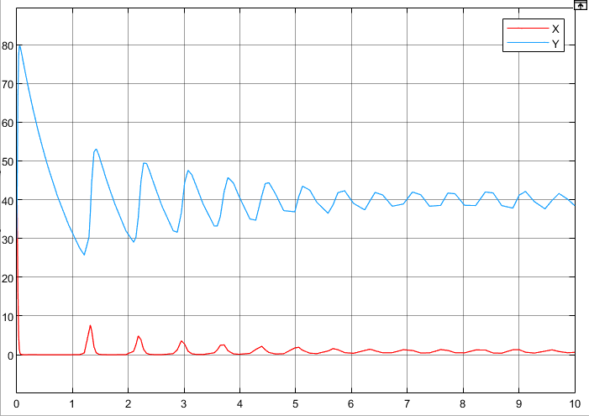
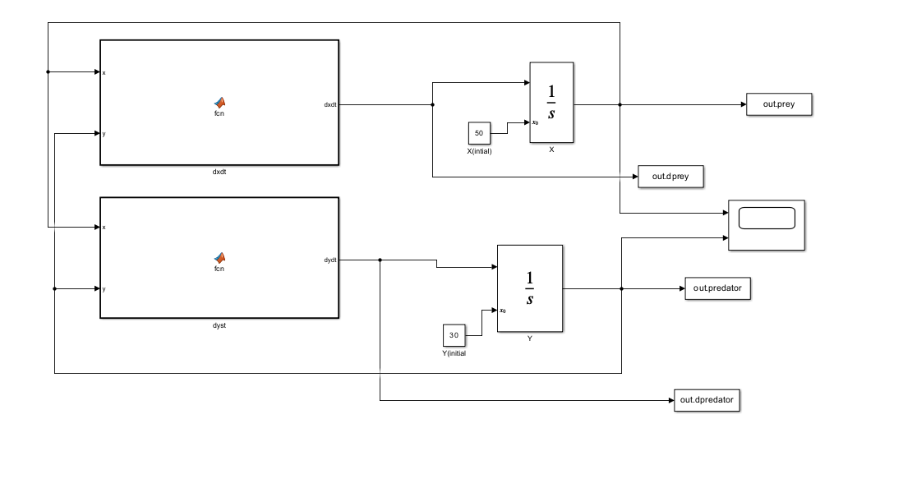
- It represents a predator prey model.
- If the x population were to disappear, then the y population would experience an increase in population until it reached carrying capacity, then the species would experience a quick decline in population due to lack of resources. If species y were to disappear, then species x’s population would expand its carrying capacity
- If x=0, dy/dt=-y → y=e^{-t} or y dies out rcxponentially
If y=0, dx/dt=100x(1-x/K) → x pop. expands to carrying capacity (100,000)

e.) The three equilibrium points are [0,0],[100,0], and [ 4/5,992/25].
f.) They are unstable I this program due to the eigen values having different signs, meaning they are going in different directions.
For [ 4/5,992/25] the eigenvalues of the linearized system (Jacobian) is -a±bi.
The REAL PART (a) is negative. That means that this is a stable Eq.Pt. Given the spiral nature of the phase plane, we can say this is a stable limit spiral, ie, the Eq.Pt. is reached asymptotically.

The population of the x species will change at a neutral rate initially, but over time the population starts to decay exponentially. Populations x and y and inverse relationships, which means that as species x declines, species y increase. The graphs also show how species x is the prey and species y is the predator due to species x’s population decrease as species y’s increases. Small additions to either population would cause a substantial difference to the predator-prey model.
(100,0) is unstable as the eigenvalues indicate. Although in the one-dimensional logistic population problem the carrying capacity is stable, in a system, it might not be. In this predator prey problem, if the prey is at carrying capacity, the introduction of a very small number of predators changes the SYSTEM completely. The predators will feast, the prey will diminish and the system will never return to (100,0)

Problem 3.)

- I chose the 3rd species model.
Model #1 is the correct answer. The text specifies:
- The bacillus and staphylococcus are in a competitive situation
- The bacillus and phage are in a predator/prey situation
- Equations 1&3 define a predator/prey scenario
- Equations 1&2 define a competitive scenario.
Please make a Simulink model. You will need 3 Matlab function blocks – one for each equation, 3 integrator blocks, etc. To avoid too many crossing arrows, write your equations in the Matlab function blocks with the numerical coefficients instead of using constant blocks. Let me know if you are struggling.

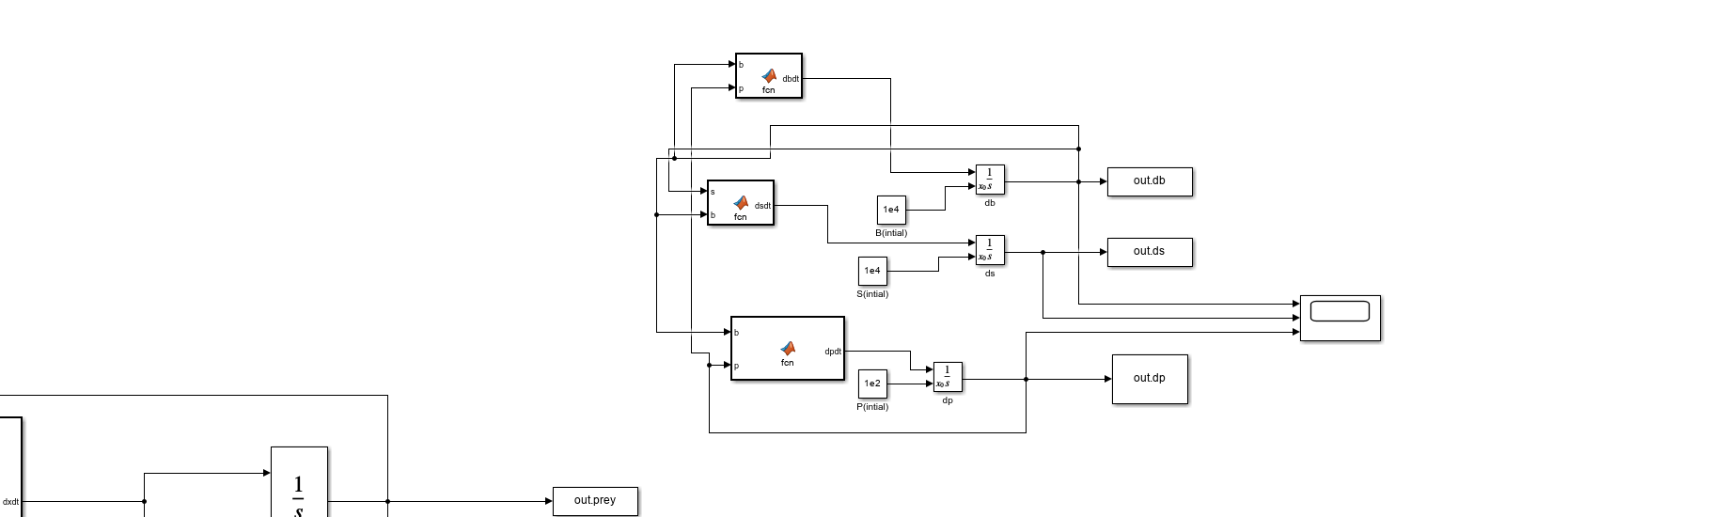

MATLAB Code
Problem 1
%Valeria Diaz Matias 1/26/2025, Homework 1: Cell Population
clear
close all
clc
%Define Carrying Capacity
K=5e8

%Define Birth Rate
r=0.56
%Define boundary condition: intitial population
Pzero=120*3000
%Define dt
dt=1/84600;
%Define length of time program should run
Tlast=25; %25 days

%The number of timesteps,iterations of the loop, will be total time divided
%by dt
iterations=Tlast/dt;
%Vector to hold value of P, the population at each timestep. Call it Pall
Pall=zeros(1,iterations);
%Track how fast the population grows, timestep by timestep. Vector dPall
%will hold this information
dPall=zeros(1,iterations);
%Creating this vector advance speeds up the calculations

%Finally define the first value of the population Pzero
P=Pzero;
for k=1:iterations
Pall(k)=P; %the first iteration, Pall(1) will be Pzero
%A new value for Pall(k) will be entered for each iteration
dP=r*P*(1-P/K); %This is our differential eq., the speed the population grows
dPall(k)=dP; %saves this value of dp/dt
P=dt*dP+P; %This new population value will be the last value of P
%plus the rate it grows/timestep times the timestep. This new value
%will be used at the start of each iteration
end
%plot form time zero to iteration-1
t=dt*(0:iterations-1); %creates time vector
%plot
figure('color','w');
plot(t,Pall,'LineWidth',2)
xlabel('TIME(DAYS)','FontSize',14, 'FontWeight','Bold')
ylabel('Population','FontSize',14, 'FontWeight','Bold')
axis([0 25 0 K+0.25e8])
title('Logistic Population Growth','FontSize',18, 'FontWeight','Bold')
grid on

%plot
figure('color','w');
plot(t,dPall,'LineWidth',2)
xlabel('TIME(DAYS)','FontSize',14, 'FontWeight','Bold')
ylabel('Rate of Change of Population','FontSize',14, 'FontWeight','Bold')
axis([0 25 0 max(dPall)+0.25e7])
title('dP/dt:Logistic Population Growth','FontSize',18, 'FontWeight','Bold')
grid on

%Find Population at 80% saturation
P80=find((Pall-0.80*K)>0,1);
T=P80*dt;
days=(floor(T))

h=rem(T,days)*24;
hours=floor(h)
m=rem(h,1)*60;
minutes=floor(m)
s=rem(m,1)*60;
seconds=floor(rem(s,1))*60
fprintf('80%% saturation will be reached in:\n')
fprintf('%2.0f days %2.0f hours %.0f minutes %2.0fseconds\n\n',days,hours,minutes,seconds)
Parray=105*(9000:1:10000)
tfinal=8;
iterationsy=round(tfinal/dt);
Pselect=zeros(2,length(Parray));
for k=1:length(Parray);
P0=Parray(k);
pop=zeros(1,iterationsy);
P1=P0;
for m=1:iterationsy
pop(m)=P1;
dPdt=r*P*(1-P1/K);
P2=dt*dPdt+P1;
end
Pselect(1,k)=pop(end);
Pselect(2,k)=P0;
end
Error=abs(Pselect(1,:)-0.8*K);
A=find(Error==min(Error));
fprintf('With a seeding density of: %5.0f cells/cm^2\n',Pselect(2,A)/105)
fprintf('The cell population in 8 days is: %6.0f\n',Pselect(1,A))
fprintf('While 80%% of the carrying capacity is: %6.0f\n',0.8*K)
fprintf('This is an error of %3.0f cells\n',Error(A))
fprintf('or an error of %1.4f %%\n\n',100*Error(A)/(0.8*K))
Szero=21000;
A=(K-Szero)/Szero;
t= 2;
Problem 2

%Equilibrium points and Jacobian for predator prey model
syms x y %defines symbolic variables
%species x
dxdt=x-x^2./100-0.25*x*y

%species y
dydt=y*(0.25*x-1);
%find equilibrium points
EqPts=solve(dxdt==0,dydt==0);
disp('Equilibrium Points:')
fprintf('[Prey, Predator]\n');disp([EqPts.x(1,1),EqPts.y(1,1)]);disp([EqPts.x(2,1),EqPts.y(2,1)]);disp([EqPts.x(3,1),EqPts.y(3,1)])
Eqns=[dxdt,dydt];
J=jacobian(Eqns);
fprintf('\n Jacobian: \n')
J1=subs(J,[x,y],[EqPts.x(1),EqPts.y(1)]);%substitues values for x and y
J2=subs(J,[x,y],[EqPts.x(2),EqPts.y(2)]);
J3=subs(J,[x,y],[EqPts.x(3),EqPts.y(3)]);
disp('Equilibrium Points:')
fprintf('[Prey, Predator]\n');disp([EqPts.x(1,1),EqPts.y(1,1)]);disp([EqPts.x(2,1),EqPts.y(2,1)]);disp([EqPts.x(3,1),EqPts.y(3,1)])
fprintf('The Jacobian of this system is :\n');disp(J)

fprintf('For Eq.Pt (%3.2f,%3.2f)\n',EqPts.x(1,1),EqPts.y(1,1))
fprintf('The Jacobian is \n'); disp(J1)

fprintf('Whose eigenvalues are: \n'); disp(eig(J1))
fprintf('For Eq.Pt (%3.2f,%3.2f)\n',EqPts.x(2,1),EqPts.y(2,1))

fprintf('The Jacobian is :\n');disp(J2)

fprintf('Whose eigenvalues are: \n'); disp(eig(J2))

fprintf('For Eq.Pt (%3.2f,%3.2f)\n',EqPts.x(3,1),EqPts.y(3,1))
fprintf('The Jacobian is :\n');disp(J3)
fprintf('Whose eigenvalues are: \n'); disp(eig(J3))

syms x(t) y(t); %now Matlab knowns that time is the independent variable
F=diff(x,t)==x-x^2./100-0.25*x*y; %define F as a differential eq. dx/dt
G=diff(y,t)==y*(0.25*x-1); %Defines G as dy/dt
solution=dsolve(F,G)
% plots for predator prey model
plot(out.prey,out.dprey)

grid on
xlabel('Time(Days)','FontSize',14, 'FontWeight','Bold')
ylabel('Population','FontSize',14, 'FontWeight','Bold')
title('Predator Prey Model','FontSize',18, 'FontWeight','Bold')
hold on
plot(out.predator,out.dpredator)
xlabel('Time(Days)','FontSize',14, 'FontWeight','Bold')
ylabel('Population','FontSize',14, 'FontWeight','Bold')
title('Predator Prey Model','FontSize',18, 'FontWeight','Bold')
hold off
Problem 3
hold on
plot(out.tout,out.db,'b','LineWidth',2)
plot(out.tout,out.ds,'r','LineWidth',2)
plot(out.tout,out.dp,'k','LineWidth',2)
hold off
grid on
xlabel('Time(hours)','FontSize',14, 'FontWeight','Bold')
ylabel('Population','FontSize',14, 'FontWeight','Bold')
title('3 Species Environment','FontSize',18, 'FontWeight','Bold')

syms b s p %defines symbolic variables
dbdt=1.25*b*(1-(b/10*10)-10^-6*p);
dsdt=2*s*(1-(s/10*10)-((1.7e4*b)/10^10));
dpdt=-(0.9)*p+(10^-6)*b*p;
EqPts=solve(dbdt==0,dsdt==0,dpdt==0)
disp('Equilibrium Points:')
disp([EqPts.b(1,1),EqPts.s(1,1),EqPts.p(1,1)]);
disp([EqPts.b(2,1),EqPts.s(2,1),EqPts.p(2,1)]);
disp([EqPts.b(3,1),EqPts.s(3,1),EqPts.p(3,1)]);
disp([EqPts.b(4,1),EqPts.s(4,1),EqPts.p(4,1)]);
disp([EqPts.b(5,1),EqPts.s(5,1),EqPts.p(5,1)]);
disp([EqPts.b(6,1),EqPts.s(6,1),EqPts.p(6,1)]);

EQns=[dbdt,dsdt,dpdt];
J=jacobian(EQns);
fprintf('\n Jacobian: \n')
J1=subs(J,[b,s,p],[EqPts.b(1,1),EqPts.s(1,1),EqPts.p(1,1)]);%substitues values for x and y
J2=subs(J,[b,s,p],[EqPts.b(2,1),EqPts.s(2,1),EqPts.p(2,1)]);
J3=subs(J,[b,s,p],[EqPts.b(3,1),EqPts.s(3,1),EqPts.p(3,1)]);
J4=subs(J,[b,s,p],[EqPts.b(4,1),EqPts.s(4,1),EqPts.p(4,1)]);
J5=subs(J,[b,s,p],[EqPts.b(5,1),EqPts.s(5,1),EqPts.p(5,1)]);
J6=subs(J,[b,s,p],[EqPts.b(6,1),EqPts.s(6,1),EqPts.p(6,1)]);

fprintf('The Jacobian of this system is :\n');disp(J)
fprintf('For Eq.Pt (%3.2f,%3.2f,%3.2f)\n',EqPts.b(1,1),EqPts.s(1,1),EqPts.p(1,1));fprintf('The Jacobian is \n'); disp(J1)
fprintf('Whose eigenvalues are: \n'); disp(eig(J1))
fprintf('For Eq.Pt (%3.2f,%3.2f,%3.2gf)\n',EqPts.b(2,1),EqPts.s(2,1),EqPts.p(2,1));fprintf('The Jacobian is :\n');disp(J2)
fprintf('Whose eigenvalues are: \n'); disp(eig(J2))
fprintf('For Eq.Pt (%3.2f,%3.2f,%3.2f)\n',EqPts.b(3,1),EqPts.s(3,1),EqPts.p(3,1));fprintf('The Jacobian is :\n');disp(J3)
fprintf('Whose eigenvalues are: \n'); disp(eig(J3))
fprintf('For Eq.Pt (%3.2f,%3.2f,%3.2f)\n',EqPts.b(4,1),EqPts.s(4,1),EqPts.p(4,1));fprintf('The Jacobian is :\n');disp(J4)
fprintf('Whose eigenvalues are: \n'); disp(eig(J4))
fprintf('For Eq.Pt (%3.2f,%3.2f,%3.2f)\n',EqPts.b(5,1),EqPts.s(5,1),EqPts.p(5,1));fprintf('The Jacobian is :\n');disp(J5)
fprintf('Whose eigenvalues are: \n'); disp(eig(J5))
fprintf('For Eq.Pt (%3.2f,%3.2f,%3.2f)\n',EqPts.b(6,1),EqPts.s(6,1),EqPts.p(6,1));fprintf('The Jacobian is :\n');disp(J6)
fprintf('Whose eigenvalues are: \n'); disp(eig(J6))
syms b(t) s(t) p(t)
F1=diff(b,t)==1.25*b*(1+(b/10^10)+(10-6)*p);
G1=diff(s,t)==2*s*(1+(s/10*10)-((1.7e4*b)/10^10));
H=diff(p,t)==-(0.9)*p+(10^-6)*b*p;
Solution=dsolve(F,G,H)

